CHAD MICHAEL COLLINS
www.ChadMichaelCollins.com

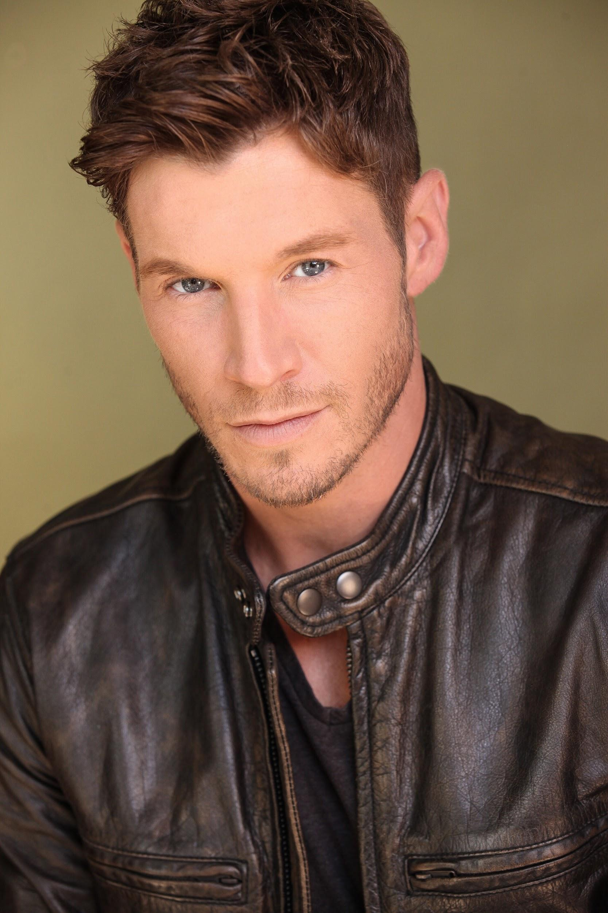
Born and raised in upstate New York, actor Chad Michael Collins landed in Los Angeles after being offered a job in entertainment public relations during college. Coming up through the entertainment industry, Collins gravitated to acting and has since gone on to amass over two dozen major television, film and video game credits.

Collins is best known for his franchise-starring role in the ongoing internationally-renowned Sony Pictures SNIPER film series. Collins first appeared as ‘Brandon Beckett’ in SNIPER: RELOADED, playing the son of Tom Berenger’s original legendary Marine sniper. He reprised his role in SNIPER: LEGACY, SNIPER: GHOST SHOOTER, SNIPER: ULTIMATE KILL, and most recently SNIPER: ASSASSIN’S END, released June 16th, 2020. Collins has shared the screen with both original SNIPER stars Billy Zane and Berenger, as well as Dennis Haysbert in the five films he has starred in.

Gamers around the world are currently enjoying playing as Collins’ ‘Alex/Echo 3-1’ character in the global smash hit CALL OF DUTY: MODERN WARFARE. Collins stars as the lead in the massively commercially and critically successful first-person shooter, the best-selling video game of 2019 and 2020, which has amassed over $2 billion with over 75 million players logging hundreds of millions of hours playing as ‘Alex’.

Collins recently re-appeared in season one of AMC Shudder’s hit horror anthology series “Creepshow” from Executive Producer Greg Nicotero (“The Walking Dead”), based on the cult classic Stephen King films. He starred in fan-favorite episode ‘Skincrawlers’, which aired on cable network AMC this past summer after a successful debut on Shudder.

Collins’ other recent credits include the starring lead role in the action-horror-western film HIGH MOON, co-starring Sean Patrick Flanery; the lead role in the holiday film “The Christmas Cabin” (Amazon); a guest-starring role as a charming fighter pilot in “MacGyver” (CBS); and a lead role in the Ion Network’s holiday rom-com “Christmas Cupid’s Arrow”.

Collins is known to sci-fi/fantasy fans for his work playing ‘Frankenstein’s Monster/Gerhart’ in ABC’s hit show “Once Upon a Time” as as the lead in the series "Extinct" (BYUtv), as well as lead roles for the SyFy Channel/Sony film LAKE PLACID 2 and SyFy’s ROCK MONSTER. His other recent TV guest-starring and recurring credits include “Shooter” (USA), “Freakish” (Hulu), “NCIS: New Orleans” (CBS), “Blue Bloods” (CBS), “Major Crimes” (TNT), “2 Broke Girls” (CBS), “Castle” (ABC), “Bones” (FOX), and a recurring role in “Last Resort” (ABC). Additional TV work includes “CSI: NY” (CBS), “CSI: Miami” (CBS), “NCIS” (CBS), “90210” (The CW), “Enlightened” (HBO), and “Ringer” (The CW). Collins also starred as the lead for Sony’s WWII action film COMPANY OF HEROES (2013), co-starring Tom Sizemore, Neal McDonough, and Vinnie Jones, which was based on the popular THQ video game franchise, as well as in the indie mockumentary ROCK BARNES: THE EMPEROR IN YOU. Collins was also recently seen starring in the Lifetime Movie Network’s “Deadly Inn” and “Dangerous Best Friend”.

----------------------------------------------------------------------------------------------------------------

A self-proclaimed “accidental” actor, Collins made his way west to Hollywood in pursuit of a public relations career after majoring in Journalism at Ithaca College. He eventually discovered acting as he continued to work as a publicist in the entertainment industry as he transitioned into his new career: playing pretend for a living.

Collins grew up in upstate New York near the state capital of Albany. An avid gamer, Collins enjoys playing his CALL OF DUTY: MODERN WARFARE game with fans around the world via Twitch, as well as playing Dungeons & Dragons. He enjoys reading comic books and fantasy novels, staying active with basketball and other sports while maintaining a fit and healthy lifestyle.

Websites and Social Media Links:
Official Website: www.ChadMichaelCollins.com
IMDB: www.IMDB.me/ChadMichaelCollins
Official Facebook: www.Facebook.com/ChadMichaelCollins
Official Twitter: @CollinsChadM
Official Instagram: @CollinsChadM
Official Twitch: Twitch.tv/ChadMichaelCollins
Official YouTube: Youtube.com/ChadMCollins32

##

